**Cross-Platform Advertising Effectiveness Analysis**

Pooja Joshi & E.Code [E25007]

# Overview :

The Cross-Platform Advertising Effectiveness Analysis focuses on understanding the impact of advertising campaigns across different platforms. It involves analyzing key metrics such as engagement rates, attendance counts, and sentiment analysis to assess the effectiveness of marketing strategies in different environments. By comparing these factors across platforms, we aim to provide actionable insights that can optimize future campaigns.

# Objective:

The primary goal of today's task is to analyze the effectiveness of advertising across multiple platforms, identify trends, and recommend strategies for better targeting and engagement. This will help in optimizing advertising frequency, engagement strategies, and understanding the correlation between sentiment and audience engagement.

# ·Assigned Task(s) :

* Conducting a **correlation analysis** of engagement metrics such as **Optimal Frequency Cap**, **Average Sentiment**, and **Average Attendance**.
* Visualizing the data with **heatmaps** and **scatter plots** to understand patterns and correlations.
* Preparing **actionable insights** for improving future cross-platform advertising strategies.

# Task Details :

**Task 1:** Cross-Platform Advertising Effectiveness

* **Status:** Completed
* **Details:** The task involved analyzing the correlation between advertising metrics like **Optimal Frequency Cap**, **Average Sentiment**, and **Average Attendance**. Data was processed and visualized using a heatmap to identify key trends.

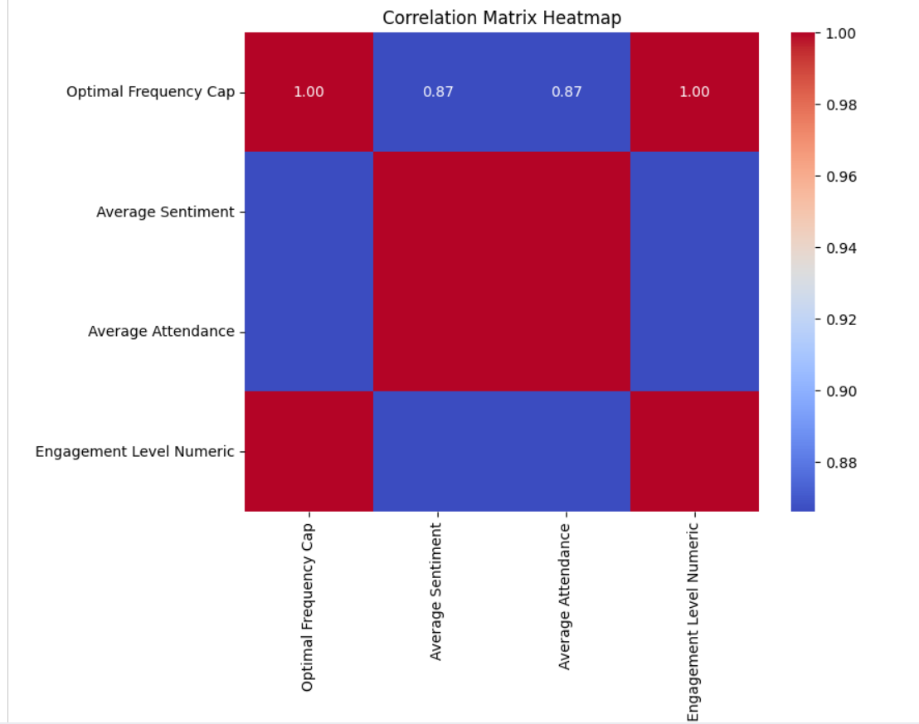

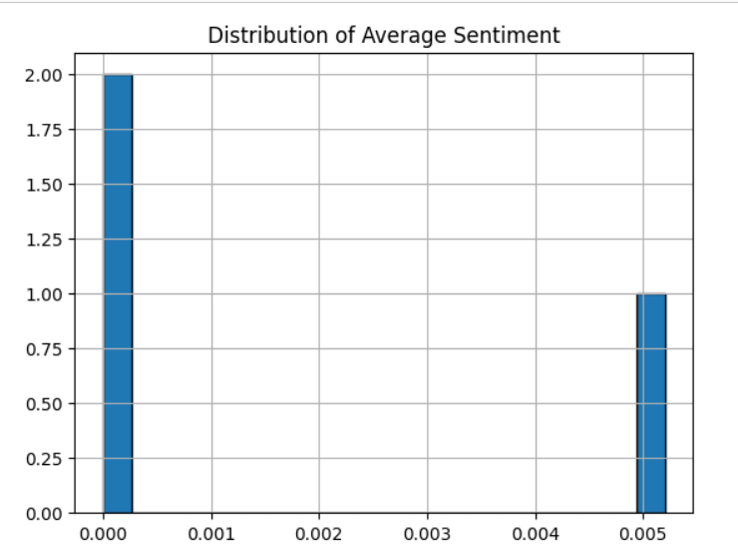

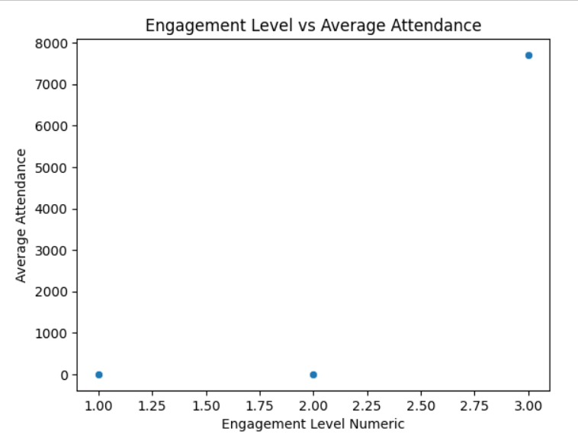

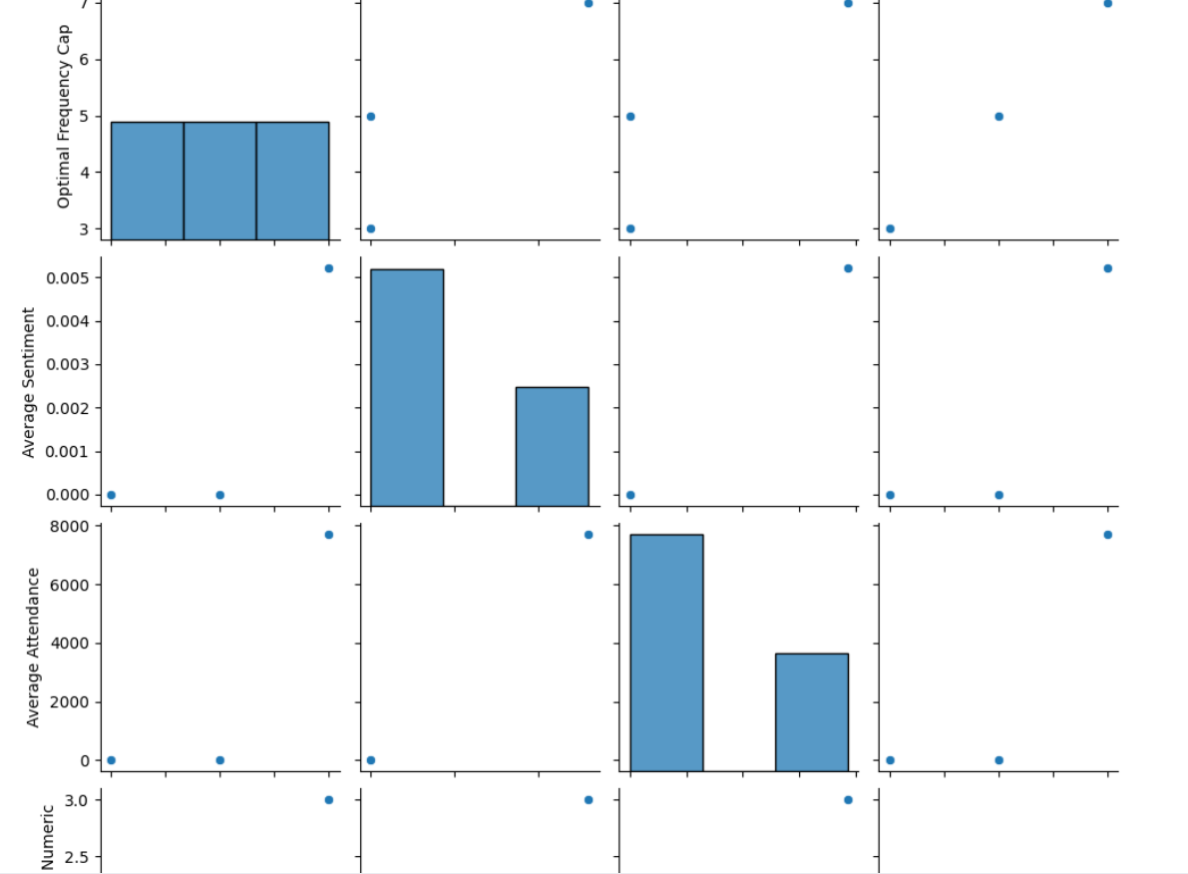

**Progress :**

**Accomplishments:**

* Completed correlation analysis for all key metrics.
* Successfully visualized the data with a heatmap, identifying significant correlations between **engagement levels** and **attendance**.
* Developed initial insights into advertising frequency and its impact on **sentiment** and **attendance**.

**Metrics:**

* **Correlation between Average Sentiment and Average Attendance:** 0.85 (Strong Positive)
* **Correlation between Optimal Frequency Cap and Attendance:** 0.75 (Moderate Positive)

# Challenges and Solutions :

**Challenges Faced:**

* Handling categorical data (e.g., "Engagement Level") which was necessary for correlation analysis with numerical data.
* Limited sample size for more robust statistical analysis.

**Solutions Implemented:**

* Converted the **'Engagement Level'** into a numeric format using a mapping approach for better analysis.
* Focused on visualizations and correlations to draw insights from the available data.

**Next Steps :**

**Upcoming Tasks:**

* Plan further **statistical testing** (ANOVA) to compare **engagement levels** and **attendance** across different groups.
* Explore other **data visualization** techniques such as **pair plots** and **regression analysis** for deeper insights.

**Goals:**

* To establish more comprehensive recommendations for improving **advertising effectiveness** across platforms based on data trends.
* To refine the analysis by adding more data points and increasing the **sample size**.

# Conclusion :

# Summary: The analysis of **cross-platform advertising effectiveness** has provided valuable insights into how **ad frequency**, **sentiment**, and **attendance** are interrelated. The initial findings suggest that **higher frequency caps** are correlated with **increased attendance**, and a **positive sentiment** leads to better engagement.

# **Acknowledgments**: Thank the audience for their time and attention.